

**American International University- Bangladesh**

**CSC 3215: Web Technologies**

**CO2 and CO4 Evaluation**

**Finished Project Report**

**Summer 2020-2021**

**Project Title: Car Rental Management System**

**Section: H**

|  |  |
| --- | --- |
| Student Name | Student Id |
| Abdullah Al Hosain | **18-38473-2** |
| Md. Milkan Islam | **18-36958-1** |
|  |  |
|  |  |

**Project Description:** Car rentals have become an integral part of travelling. Asphalt Car Rental website revolutionizes the entire scenario by providing affordable, convenient, and quick transport systems. Our website contains.

**Easy Bookings:** Our user needs to create an account before booking the ride, the registration forms will be short and to the point; long-winded forms are a big no. Asphalt car rental website is allowing bookings in real time as well as for advanced time periods. Depicting the availability of the various cars on a monthly interface can help our users select their preferences from the pool and reserve dates easily.

**Flexible Plans:** Asphalt Car Rental maintains flexible plans for bookings, such as one-way trips, local and long-distance packages help the customers choose one according to their convenience. Providing with a simple payment method on a daily basis.

**Mobile Ready:** The maximum percentage of rental car users’ books cars over mobile phones. So, we’ve thought this through and made our website fully imperative to be responsive, to cater successfully to the entire potential market.

**Quick and Secure Payments:** Asphalt Car Rental website has integrated, secure payment gateways that lets our users’ complete transactions quickly, in a hassle-free manner. For aggregator models, it is possible to offer optional cash collections, where the user pays the driver directly upon fulfilment of the journey; the company takes its cut as part of the commission from the driver.

**Tracking:** Keeping track of the inventory of cars is necessary to ensure that the availabilities are updated on the bookings calendar accordingly. Real-time inventory updates help prevent overlapping of bookings and by extension.

**Member Profiles:** Generating user profiles for our frequent users creates a customer database that can be accessed whenever the user is next filling a form or adding information, to auto-fill the required fields. All of our members information will be stored in the database for every safety and future form fill-up scenarios.

Localization: We have localized our website, as per the area of operation, goes a long way in facilitating quicker bookings.

**Project Folder Structure:**

C:\xampp\htdocs\Webtech\Mid

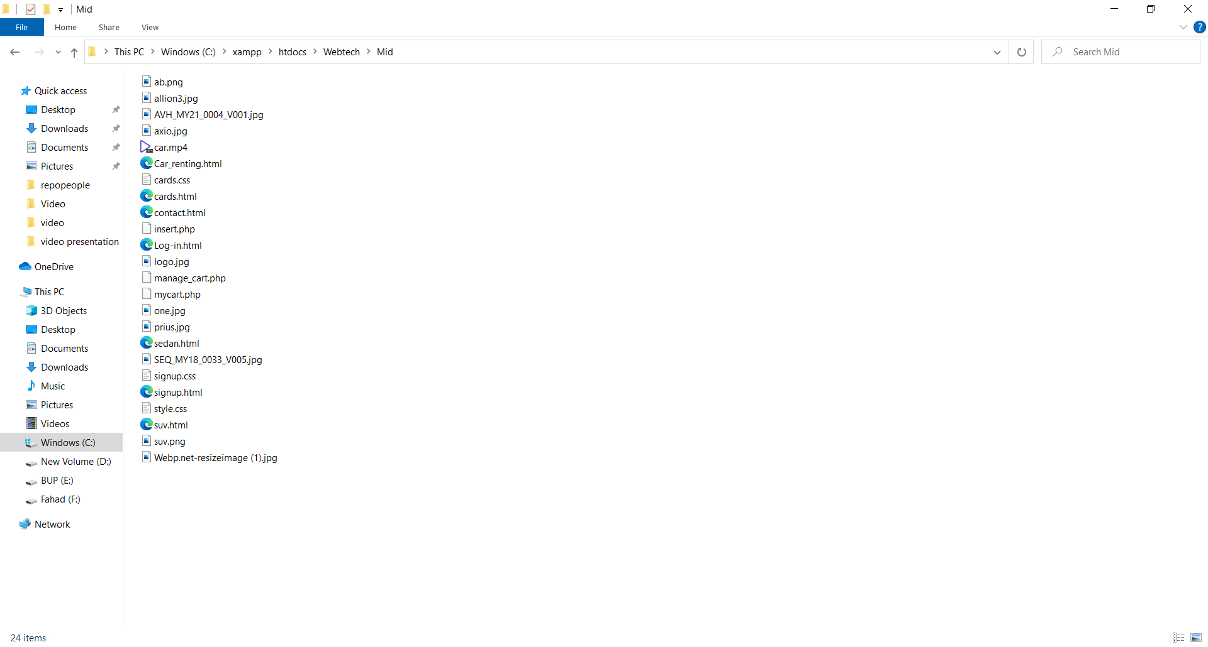

**Core Modules of the Project:** Here is three core module of the project is given bellow:

**First module:**

Html code: <!DOCTYPE html>

<html lang="en">

<head>

<title>CAR RENT</title>

<link rel="stylesheet" href="style.css">

</head>

<body>

<header>

<button><a href="signup.html">Sign-Up</a></button>

<button id="loginButton"><a href="Log-in.html">Log-In</a></button>

</header>

<div>

<h1 class="companyName">Asphalt Car Rental</h1>

<button><a href="">HOME</a></button>

<button><a href="">About Us</a></button>

<button><a href="cards.html">Car List</a></button>

<button><a href="contact.html">Contact Us</a></button>

</div>

<video autoplay loop muted class="video_editor">

<source src="car.mp4" type="video/mp4">

</video>

</body>

</html>

Css code:

body {

width: 100%;

height: 100%;

margin: 0;

padding: 0;

}

#heading{

text-align:center;

font-family: 'Montserrat', sans-serif;

font-size: 60px;

font-weight: 500;

color: chartreuse;

}

.cards {

margin-top: 30px;

margin-bottom: 30px;

margin-left: 30px;

margin-right: 30px;

align-items: center;

border-radius: 10px;

background-color: #FFE4E1;

}

.title {

padding: 10%;

}

.image img {

width: 100%;

border-top-right-radius: 10px;

border-top-left-radius: 10px;

}

.btn {

background-color: #4CAF50;

border: none;

margin-top: 20px;

margin-bottom: 20px;

color: white;

padding: 10px 25px;

text-align: center;

text-decoration: none;

display: inline-block;

font-size: 16px;

border-radius: 5px;

}

Image of the page:

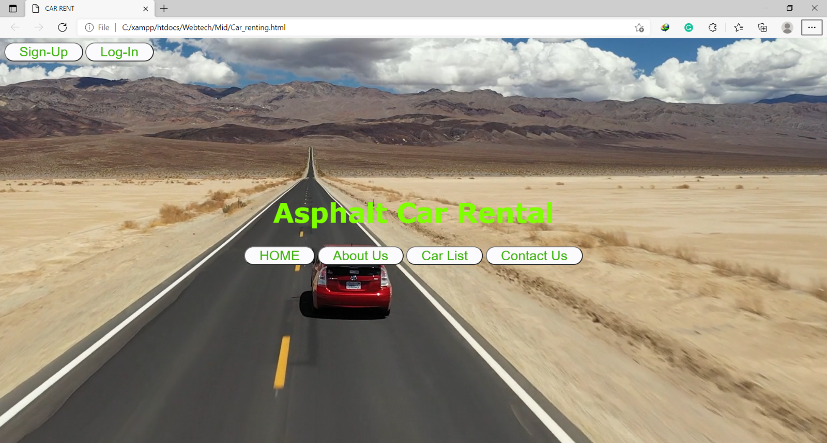

**Second module:**

Html code:

<!DOCTYPE html>

<html lang="en">

<head>

<meta charset="UTF-8">

<meta http-equiv="X-UA-Compatible" content="IE=edge">

<meta name="viewport" content="width=device-width, initial-scale=1.0">

<title>Sign-Up</title>

<link rel="stylesheet" href="signup.css">

</head>

<body background id="bg">

<p class="heading"> Welcome To Asphalt Car Rental</p>

<p class="heading">Fill The Form To Sign-Up</p>

<form action="insert.php" method="POST">

<table align="center" id="table">

<tr>

<td>

Name :

</td>

<td>

<input type="text"placeholder=" Name" name="Username" class="fn" required>

</td>

</tr>

<tr>

<td>

Password :

</td>

<td>

<input type="password"placeholder="Set Password" name="password" class="fn" required>

</td>

</tr>

<tr>

<td>

Gmail :

</td>

<td>

<input type="gmail"placeholder="Enter Gmail" name="gmail" class="fn" required>

</td>

</tr>

<tr>

<td>

Gender :

</td>

<td>

<input type="radio" name="gender" value="m" required>Male

<input type="radio" name="gender" value="f" required>Female

</td>

</tr>

<tr>

<td>

Mobile Number :

</td>

<td>

<select name="phonecode" id="" class="fn" required>

<option selected hidden value="">Select Code</option>

<option value="+880">+880</option>

<option value="+93">+93</option>

<option value="+46">+46</option>

<option value="+97">+97</option>

<option value="+65">+65</option>

<option value="+69">+69</option>

<option value="+420">+420</option>

</select>

<input type="Phone" name="phone" placeholder="Enter mobile number" class="fn" required>

</td>

</tr>

<tr>

<td>

<input type="submit" value="Submit" class="fn">

</td>

</tr>

</table>

<p id="footer" align="center">

<button>

<a href="Car_renting.html">Go To Home</a>

</button>

<button>

<a href="Log-in.html">Go To Log-In</a>

</button>

</p>

</form>

</body>

</html>

Css code:

#bg{

background-color: cornflowerblue;

background-image: url(ab.png);

}

.heading{

text-align:center;

font-size: 50px;

color: chartreuse;

}

button{

background: white;

border-radius: 25px;

font-size: 20px;

}

button a{

color: chartreuse;

margin: 5px;

text-decoration: none;

}

#table{

text-align: center;

font-size: 40px;

color: chartreuse;

border: 5px solid green;

border-radius: 40px;

padding: 20px;

}

.fn{

background-color: rgb(245, 247, 245);

font-size: 30px;

}

Picture of the page:

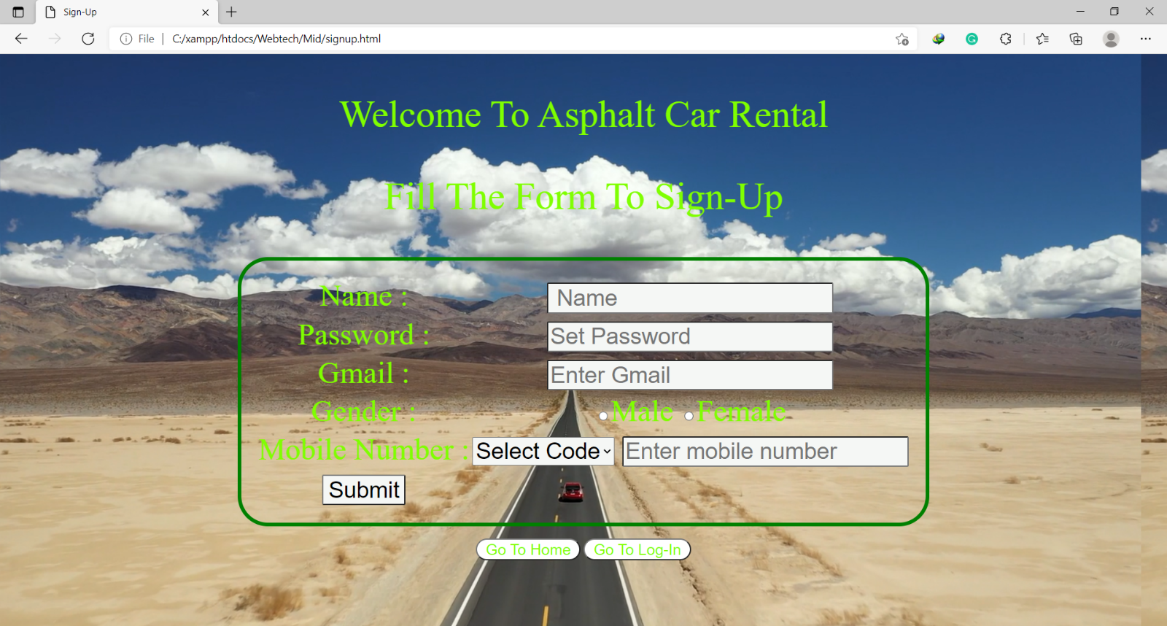

**Third module:**

Html code:

<!DOCTYPE html>

<html lang="en">

<head>

<meta charset="UTF-8">

<meta name="viewport" content="width=device-width, initial-scale=1.0">

<meta http-equiv="X-UA-Compatible" content="ie=edge">

<link rel="stylesheet" type="text/css" href="file:///C:/Users/Tahin/Music/WEB%20TECH/cards.css">

<link rel="preconnect" href="https://fonts.gstatic.com">

<link href="https://fonts.googleapis.com/css2?family=Montserrat&display=swap" rel="stylesheet">

<title>Asphalt Car Rental</title>

<link rel="stylesheet" href="cards.css">

</head>

<body>

<header>

<button class="btn"><a href="Log-in.html">LOGOUT</a></button>

<button class="btn"><a href="Car_renting.html">HOME</a></button>

<h1 id="heading">Asphalt Car Rental</h1>

</header>

<!-- cards-->

<section class="box">

<div class="cards">

<div class="image">

<img src="AVH_MY21_0004_V001.jpg" />

</div>

<div class="title">

<h1 style="text-align:center; font-family: 'Montserrat', sans-serif;">Sedan</h1>

</div>

<div class="description" style="text-align:center; font-family: 'Montserrat', sans-serif;">

<p>

write your car description here...

</p>

<button class="btn"><a href="sedan.html">Read more...</a> </button>

</div>

</div>

</section>

<!--cards-->

<section class="box">

<div class="cards">

<div class="image">

<img src="SEQ_MY18_0033_V005.jpg" />

</div>

<div class="title">

<h1 style="text-align:center; font-family: 'Montserrat', sans-serif;">SUV</h1>

</div>

<div class="description" style="text-align:center; font-family: 'Montserrat', sans-serif;">

<p>

write your car description here...

</p>

<button class="btn"><a href="suv.html">Read more...</a></button>

</div>

</div>

</section>

<!--cards-->

<section class="box">

<div class="cards">

<div class="image">

<img src="Webp.net-resizeimage (1).jpg" />

</div>

<div class="title">

<h1 style="text-align:center; font-family: 'Montserrat', sans-serif;">MicroBus</h1>

</div>

<div class="description" style="text-align:center; font-family: 'Montserrat', sans-serif;">

<p>

write your car description here...

</p>

<button class="btn"><a href="">Read more...</a></button>

</div>

</div>

</section>

</body>

</html>

Css code:

body {

width: 100%;

height: 100%;

margin: 0;

padding: 0;

}

#heading{

text-align:center;

font-family: 'Montserrat', sans-serif;

font-size: 60px;

font-weight: 500;

color: chartreuse;

}

.cards {

margin-top: 30px;

margin-bottom: 30px;

margin-left: 30px;

margin-right: 30px;

align-items: center;

border-radius: 10px;

background-color: #FFE4E1;

}

.title {

padding: 10%;

}

.image img {

width: 100%;

border-top-right-radius: 10px;

border-top-left-radius: 10px;

}

.btn {

background-color: #4CAF50;

border: none;

margin-top: 20px;

margin-bottom: 20px;

color: white;

padding: 10px 25px;

text-align: center;

text-decoration: none;

display: inline-block;

font-size: 16px;

border-radius: 5px;

}

Image of the page:

